NAME – N.SHIVANI

REGISTRATION NO -
MODULE NAME – APPLIED AI [MD - 11]

Project Title
Student Performance Prediction System Using Random Forest Classification

AIM
1. Building a Student Performance Prediction System using GitHub
Problem:
To creating a machine learning project that predicts whether a student will pass or fail based on study hours, attendance, and previous scores. The project must be managed using GitHub with proper version control.
Task
- Create GitHub Repository
- Load and Explore Dataset
- Preprocess Data
- Train ML Model
- Push Code & Collaborate

Objective
The objective of this project is to develop a Machine Learning model that predicts whether a student will pass or fail based on factors such as study hours, attendance percentage, and previous examination scores. The project is managed using GitHub for version control and collaboration.

Problem Statement
Educational institutions often need to identify students who are at risk of failing so that timely interventions can be provided. This project uses Machine Learning techniques to predict student performance based on academic and attendance-related factors.

Technologies Used
- Python
- Pandas
- Scikit-learn
- Joblib
- Git
- GitHub

Dataset Description
The dataset contains the following attributes:
Attribute | Description
StudyHours | Number of hours studied per day
Attendance | Attendance percentage
PreviousScore | Previous examination score
Pass | Target variable (1 = Pass, 0 = Fail)
Sample Dataset:
StudyHours | Attendance | PreviousScore | Pass
2 | 60 | 40 | 0
5 | 75 | 55 | 1
8 | 90 | 70 | 1
1 | 50 | 30 | 0

Methodology

Step 1: Load Dataset
The dataset is loaded into a Pandas DataFrame using the read_csv() function.

Step 2: Data Exploration
The dataset is examined to:
- View records
- Check missing values
- Understand feature distribution

Step 3: Data Preprocessing
The dataset is divided into:
- Features (StudyHours, Attendance, PreviousScore)
- Target Variable (Pass)

Step 4: Train-Test Split
The dataset is split into:
- 80% Training Data
- 20% Testing Data

Step 5: Model Training
A Random Forest Classifier is used to train the model on the training dataset.

Step 6: Model Evaluation
The trained model is evaluated using:
- Accuracy Score
- Confusion Matrix

Step 7: Prediction
The system accepts new student details and predicts whether the student is likely to pass or fail.

Step 8: Save Model
The trained model is saved using Joblib for future predictions.

Algorithm Used

Random Forest Classifier
Random Forest is an ensemble machine learning algorithm that combines multiple decision trees to improve prediction accuracy and reduce overfitting.
Advantages:
- High accuracy
- Handles large datasets efficiently
- Reduces overfitting
- Easy to use and interpret

Implementation Steps
- Import required libraries.
- Load the dataset.
- Explore and preprocess the data.
- Split the dataset into training and testing sets.
- Train the Random Forest model.
- Evaluate model performance.
- Save the trained model.
- Predict student performance using new input values.

Results
The Random Forest model successfully predicts student performance based on study hours, attendance, and previous scores. The model can help educators identify students who may require additional academic support.
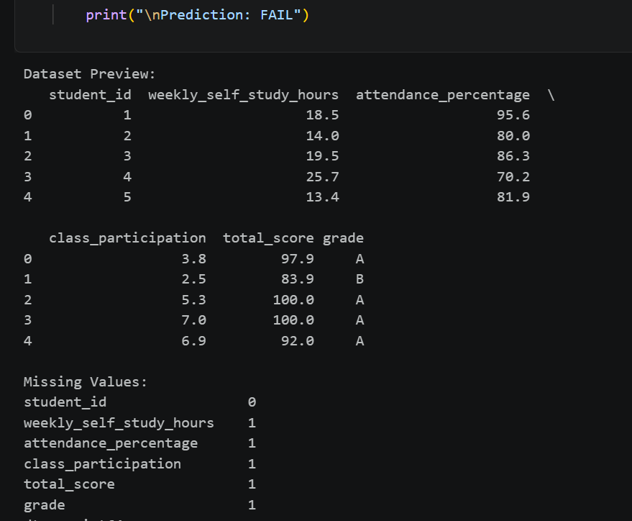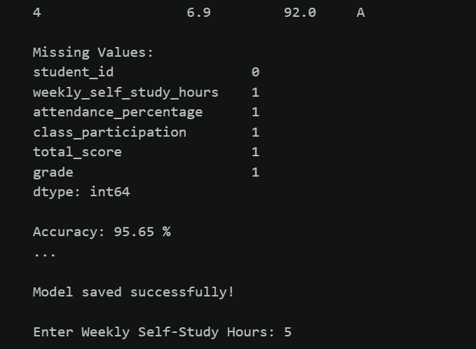

Conclusion
This project demonstrates how Machine Learning can be applied in the education sector to predict student outcomes. By using historical student data, the system provides valuable insights that can assist teachers and institutions in improving student performance and reducing failure rates.

